E-Bus Ticketing System

Synopsis of Project submitted to

**CSJM UNIVERSITY**

IN FULFILMENT OF DEGREE OF

**BACHELORS OF COMPUTER APPLICATION (BCA)**

SESSION 2020-2023

BY

**Nikhil Maurya**

**Roll No.**

**0303965**

**Project In charge**

**Amit Yadav**

**(Faculty)**

**Dr. VSICS, Kanpur**

**Undertaken at:**



**Dr. Virendra Swarup Institute of Computer Studies Kanpur**

**Index**

**Acknowledgement**

**Introduction**

The traditional bus ticketing system is often associated with long queues and delays, making it a tedious and time-consuming process for passengers. Moreover, with the recent COVID-19 pandemic, there has been a growing demand for contactless transactions to minimize the risk of transmission. To address these challenges, the e-bus ticketing system using QR code presents a modern and efficient solution for bus operators and passengers.

We have assured the faster and safer transactions with proper validation of the particular passenger’s ticket fees. Although we have integrated the system in a single program but when it will actually operable then we may make it to many fractions and assign many roles such as:

1. Admin (backend manager)
2. Agent (for recharging passengers)
3. Operator (the bus conductor who uses this to collect the fees)
4. Passenger (who has his QR-code containing information name@addharnumber).

**Objective**

This project aims to develop a comprehensive e-bus ticketing system that utilizes QR codes to facilitate a hassle-free and contactless ticketing experience for passengers. With this system, passengers can easily purchase and validate their tickets through a mobile application, eliminating the need for physical tickets or cash transactions. Bus operators can also manage their routes and ticket sales through a back-end system, providing real-time data on ticket sales and passenger traffic.

The use of QR codes in this system provides numerous benefits, including faster ticket validation, reduced waiting time for passengers, and improved accuracy in ticket validation. Furthermore, with the growing popularity of smartphones and mobile devices, the adoption of this system is expected to be high among passengers.

Overall, the e-bus ticketing system using QR code presents a modern and innovative solution to the challenges faced by traditional bus ticketing systems. It is a step towards a more efficient and convenient mode of transportation for both bus operators and passengers.

**The Working Algorithm**

The Algorithm of the project e-bus ticketing system is that it is mainly divided into following parts:

1. Database Creation (Named ‘passenger_details’)
2. Connection to database
3. New passenger (Registration of passenger)
4. Login
5. Scan for Entry
6. Scan for Exit

These are main modules used to complete this whole project the main external modules which are used in its source code to create it are as follows:

* FPDF
* qrcode
* tkinter
* messagebox
* tkinter.messagebox as tmsg
* PIL
* mysql.connector
* datetime
* os
* web browser

1. **Database Creation:**

We need to create a base database and a main table named personal for storing personal information of the passengers so that the further operations can occur.

We have two external supportive files for creation of base database named:

* Database_creationFile.sql (SQL file)
* PythonScriptToCreateMainDB.py (python script file)

There are 8 entities in the personal table of the database. We have to used many of the details in this table to perform various operation like login scan in scan out etc. The E-R diagram for that is at Next page please visit

Another sub Tables is needed in this database to store various transaction records and calculation module this is abbreviated as nameofpassengerAadharofpassenger by merging the name of passenger and his Aadhar the name of a table might look like:

Name-Abhav Yadav

Aadhar-123456789012

So, the table name will look like: ‘Abhavyadav123456789012’

E-R Diagram of personal

Passenger

Email

state

Total_balance

Gender

Aadhar

password

Mobile_no

Name

departure_time

statement

total_balance

amount_difference

**TransitionId**

board_time

E-R Diagram of sub-table

nameAadhar

1. **Connection to database:**

For connection of database, we have a function named as connect_To_DB and its belonging functions which uses mysql.connector module mainly. It asks user his password if default password is incorrect and saves it to a file named as ‘pass.txt’ in same directory where whole source code is present. It uses following algorithm:

1. Try reading ‘pass.txt’
2. If ‘pass.txt’ exists then redline which is password saved before
3. Else increment flag
4. Try connecting to database
5. If exception occurs it means password is wrong and asks user again for password of database.
6. New passenger:

It is an admin or agent side operation which is responsible for registration of new passenger by GUI based frame pop up technologies used in this function is Tkinter and MySQL connector.

This New passenger is a menu and has six GUI based labels and entries named as follows:

* Name
* Gender
* Mobile_no
* Email
* Aadhar
* Password

And in last there is a button named as Register which when pressed validates the data and it the data entered is valid then it saves it into the database named as passenger_details’ personal which we have earlier created by python scripts provided in the package. There is various validation function which resists users entering wrong data or and inappropriate data that can crash or confuse the database system. Such that:

* Callback
* Callback1
* Callback2

1. Login:

This module is very important for various operations the main credentials use in this are Aadhar and password. We are using login by two methods:

* By QR code
* By Aadhar and password

**By Aadhar and password:**

We have a login method in the module for this operation and supporting methods which takes value as argument which defines the various operations like:

* De-activation
* Recharge
* Get Records
* Get QR code

**By QR code:**

We call it indirect method which is used by passenger to transit the fees of transportation by automation. We have discussed it brief in next Heading please refer to that for details. This takes name and Aadhar of user to get logged in for accessing the database of user and performing transitional operations like calculation and updating of records in sub table.

1. **Scan for Entry:**

Passengeruse this feature when they have to board in to the bus for this operation, we have function called entry_bus and supporting methods such as savedata which and uses sub table of the that particular passenger name like name + Aadhar -> ‘raddha123456789873’ in which the algorithm goes like:

* + 1. Start
    2. QR scanned
    3. Extract data from that
    4. Pass data to savedata function
    5. Perform some validation
    6. Auto increment TransitionId and save board time
    7. Update the state value to 1
    8. Exit

1. **Scan for Exit:**

Passenger use this feature when they have to leave the bus an deduce his fees for departure and so when have to calculate the amount and save the information in the database and also fetch some data from database so hence there are is a function for performing this operation named as exit_bus and supporting functions for this to do some side calculation and operation to execute the need. For this we have this Algorithm:

1. Start
2. Scan QR code
3. Extract data from it
4. Send it to a supporting function named as calculate
5. Perform validations
6. Trim the data into information we need
7. Fetch data from database such as board time
8. Calculate the total money by passing it to the moneycal function
9. The moneycal function calculates the cost by 1sec travel=1/60 unit money and return it
10. Show the message and save the record to the database
11. Exit

So hence, like this the modules of the whole project. We have integrated all the modules in a single program because it is a prototype module we need to disintegrate the modules once it will be on the actual production use .We also have some side modules which help it to work efficiently These helping modules completes the modules operations so that they can be used by users or backend admit to perform some specific operations some of them are as follows:

1. Recharge
2. Deactivation
3. Get QR
4. Get records

**Hardware and Software requirements**

For hardware requirements we Don’t need anything any so specific but we are using QR as our core Idea so we need following hardware:

Laptop including following things:

1. 4GB of ram and 2.5 GHz of processing power
2. Webcam
3. Basic I/O devices

For software we need some software and a basic and general purpose software running environment we need following software:

* Python (3.11.0)
* MySQL (8.0.32)
* MySQL server (8.0.32)

For development I used Microsoft’s visual studio Code as an IDE for better interface debugging and testing.

The version of my V. S. code is 1.76. Which is very good and stable for development of any GUI based application using python Tkinter or any GUI Based technology.

**Data flow diagram**

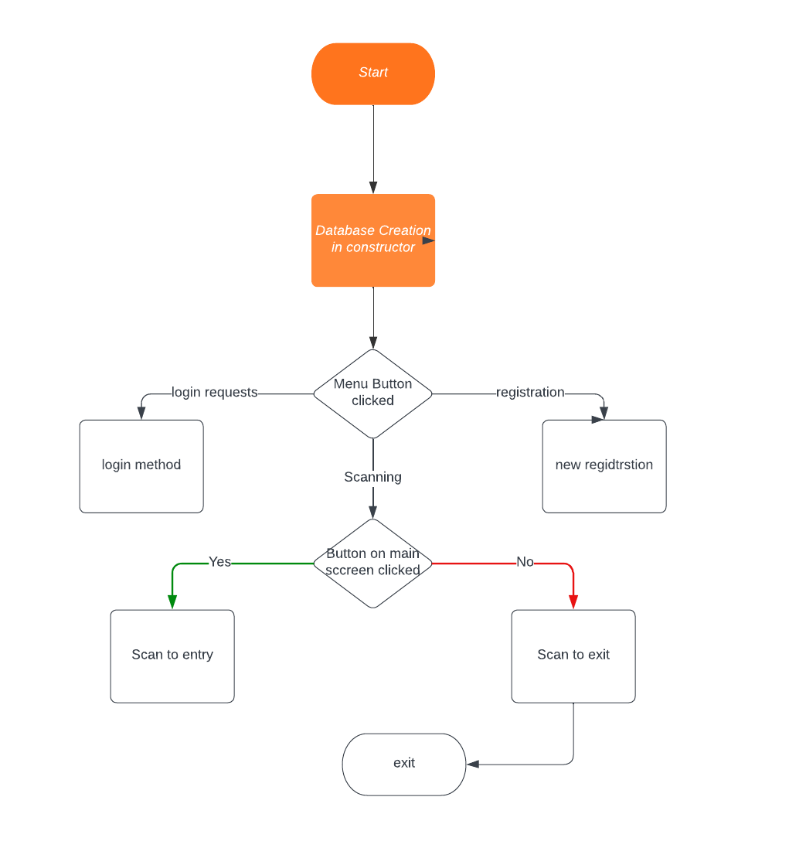

**Current Problems and area of improvement**

Current Problems:

1. Long queues and delays in traditional bus ticketing systems
2. Physical ticketing can be lost, damaged or misplaced
3. Risk of cash transactions and physical contact during the COVID-19 pandemic
4. Inefficient data management and ticket sales tracking by bus operators
5. Lack of real-time data on passenger traffic and ticket sales

Areas of Improvement:

1. Faster and more convenient ticket purchasing process for passengers
2. Contactless and safer ticketing experience for passengers during the COVID-19 pandemic
3. Real-time data on passenger traffic and ticket sales for bus operators to optimize their services
4. Accurate and efficient ticket validation process for bus conductors
5. Efficient and centralized data management system for ticket sales tracking by bus operators

**Future or Scope of the project**

The scope of the e-bus ticketing system using QR code project involves the development of a comprehensive ticketing solution that leverages QR codes to facilitate a seamless and contactless ticketing experience for passengers. The project will cover the following aspects:

1. Mobile Application Development:

A mobile application will be developed for passengers to purchase and validate tickets. The application will allow passengers to select their desired bus routes, view ticket prices, and purchase tickets using various payment options.

1. QR Code Generation:

A unique QR code will be generated for each ticket purchased through the mobile application. The QR code will serve as the ticket and will be scanned by bus conductors to validate the ticket.

1. Back-End System Development:

A back-end system will be developed for bus operators to manage their routes, ticket sales, and passenger data. The system will provide real-time data on ticket sales and passenger traffic, allowing operators to optimize their services based on demand.

1. QR Code Scanner Integration:

A QR code scanner will be integrated with the system to validate tickets. The scanner will be installed on buses and used by conductors to scan the QR codes on passengers' tickets.

from the traditional ticketing system to the new e-bus ticketing system using QR code.

The scope of this project is to deliver a fully functional and integrated e-bus ticketing system that enhances the overall efficiency of bus services, reduces waiting time for passengers, and provides a safer and contactless ticketing experience.

**Conclusion**

In conclusion, the e-bus ticketing system using QR code presents a modern and innovative solution to the challenges faced by traditional bus ticketing systems. By leveraging the power of QR codes and mobile applications, this system provides a fast, safe, and efficient ticketing experience for passengers while also streamlining ticket sales and passenger data management for bus operators.

The development of this system represents a significant step towards a more efficient and convenient mode of transportation for both bus operators and passengers. It is expected to reduce waiting times, improve the accuracy of ticket validation, and provide a contactless and safer ticketing experience, especially during the current COVID-19 pandemic.

Overall, this project provides a comprehensive and practical solution to the challenges faced by traditional bus ticketing systems. The e-bus ticketing system using QR code is an excellent example of how technology can be leveraged to enhance the efficiency and convenience of public transportation systems.